

* ACKNOWLEDGEMENT
* ABSTRACT

1. **INTRODUCTION**

  ABOUT THE PROJECT

1. **SYSTEM REQUIREMENT**

  HARDWARE REQUIREMENT

  SOFTWARE REQUIREMENT

1. **PROBLEM DEFINITION AND PROPOSAL**

  INTRODUCTION

* EXISTING SYSTEM
* PROPOSED SYSTEM

**4. SYSTEM DESIGN**

  FLOW CHART

* MODULE DISCRIPTION AND SCREENSHOTS

1. **TESTING**

  TESTING BASED ON ENTRIES

  VALIDATION CHECK

* + 1. **CONCLUSION AND FUTURE ENHANCEMENT**
* CONCLUSION
* FUTURE ENHANCEMENT
* REFERENCE

**ACKNOWLEDGEMENT**

We take this opportunity to express our profound gratitude and deep regards to our faculty PROF **Mr. KABANI** for his exemplary guidance, monitoring and constant encouragement throughout the course of this project. The blessing, help and guidance given by him time to time shall carry us a long way in the journey of life on which we are about to embark.

We are highly obliged to our project team members for the valuable information provided by them in their respective fields. We are grateful for their cooperation during the period of our assignment.

**ABSTRACT**

The adoption of Electronic Banking by commercial enterprises has been in existence since the mid 90’s, much greater in number due to lower operating costs associated with it. Electronic banking has initially been in the form of automatic teller machines and telephone transactions. More recently a new delivery channel for banking services that benefits both customers and banks is in implementation i.e. using computers.

In this proposed interface, manager and accountant have access to the customer’s account, and manager have special preference to access all details of banking system.

Banking system services can include:

* Client
* Front Office Advisors
* Managers

**INTRODUCTION**

A Bank is a commercial or state institution that provides financial services, including issuing money in form of coins, bank notes or debit cards, receiving deposits of money, lending money and processing transections. A commercial bank accepts deposits from customers and in turn makes loan based on those deposits.

This project is basically providing a full service user friendly interface primarily specializing in Banking Management System;

We are using following details of clients:

* Client ID
* First Name
* Last Name
* Photo
* Date Of Birth
* Account Type
* Gender
* Telephone
* Address
* Occupation
* Nationality
* Martial Status
* Email ID

The bank will provide following functionalities to clients:

* Create his account
* View and modify their personal information
* View the balance and transaction history of their accounts
* Extract statements of account(s) in .csv format
* Make a Transfer(Internal or external)
* Feed and account
* Viewing transections of deposit.The bank will provide the functionalities to the Front office advisers:
* See the list of clients
* View clients personal information
* View the balance and transaction history of all client accounts

The bank will provide following functionalities to managers:

* + View the sum of customer deposit in defined period
  + Generate reports on customer activities in defined period
* We will provide an email alert to the customer after the account creation providing them with their account numbers.
* We will also provide email alert for each deposit and withdrawal of money from his/her account.

**SYSTEM REQUIREMENTS**

HARDWARE REQUIREMENT

* Laptop Intel i3 3rd Gen clock speed 2.5 GHz and above.
* Hard disk : min. 10 GB
* Ram : 1 GB
* Monitor resolution : 800 X 600

SOFTWARE REQUIREMENT

* ANY Operating System (Windows 10 / 8, Linux, Mac)
* JDK 8 (Java Development Kit)
* JRE 8 (Java Runtime Environment)
* Language Used : JAVA 8
* Eclipse Neon IDE
* File system

**PROBLEM DEFINITION AND PROPOSAL**

INTRODUCTION

In proposed system, the management needs not to keep any type of registers, which they use to keep in old one. They have work only with one computer. All the details are stored in computer files. The dual entries are done very quickly as entry in one file only , affects the other file where it has to record. In the way there is no need to record the computer operator.

The working through registers system is not only very laborious and time consuming , but there are number of errors found. In comparison to old system the proposed system of computer processes many advantages.

Some of the merits of proposed system are as follows:-

* **Accuracy:-**

It is one of the features of computer that it provides accuracy result. It is often said, “Man does mistakes but machines never”. When a man works there seems numbers of errors and mistakes in performing calculation and other things, while it is not in case with computers.

* **Security:-**

|  |  |  |  |  |
| --- | --- | --- | --- | --- |
| The | security is maintained vary comfortably in computers. | | Secretes | are |
| not | disclosed off, as there are password settings in | the | computers. | So |
| the firm can get the benefit of non-disclosure of | | its | secrets to | the |
| outsider competitors as well as other non-authorized | | persons. | |  |

* **Time saving:-**

The computerized system is time saving. On an immediate inquiry , the operator or any authorized person has to just click some switches and get the information in few seconds.

* **Perform Repetitive Task Very Well:-**

It is said that computer never tires. I do the repetitive task very well as it never feels laziness. Performance of repetitive task by a man is not well Performed, as main tires very quickly and feels lazy. It is not in the case with computer. So, proposed system is beneficial than Old one.

**EXISTING SYSTEM**

Presently there is no such system available. Some are there with limited access and following limitations:

* Time consuming…
* More expensive…
* Searching problem…
* Maintains problem of all registers…
* Less accuracy…
* Problem for marking of not normal value…

**PROPOSED SYSTEM**

In our system we are looking forward to provide following advantages to users:

* Time saving…
* Less expensive…
* Powerful searching…
* Solve the problem of maintains register…
* More accuracy…
* Easy generate report…
* Not display multiple reports…

**UML DIAGRAM**

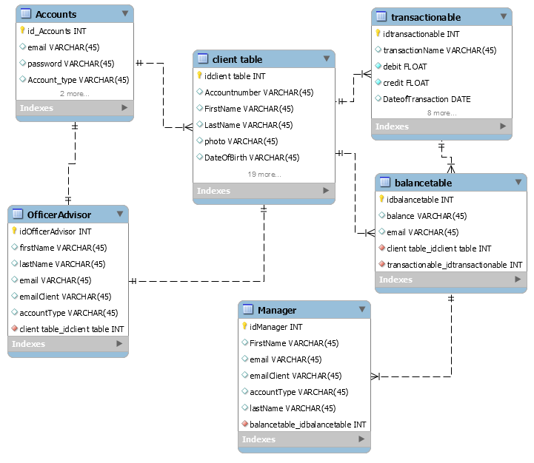

**MODULES DESCRIPTION AND SCREENSHOTS**

* WELCOME FRAME

This page will redirect to login page. This page is common for client, advisor & Manager .

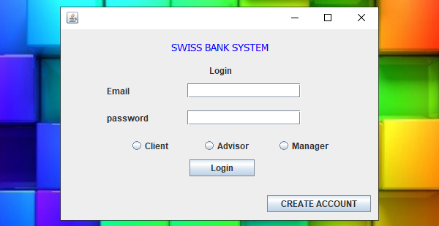

Creating An Account :

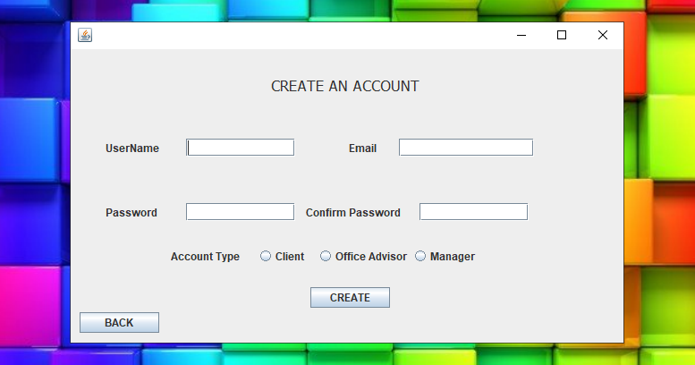

CLIENT INFORMATION:

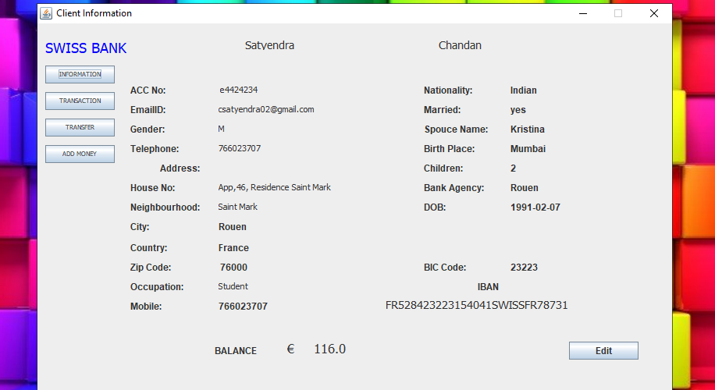

CLIENT PERSONAL DETAILS EDIT:

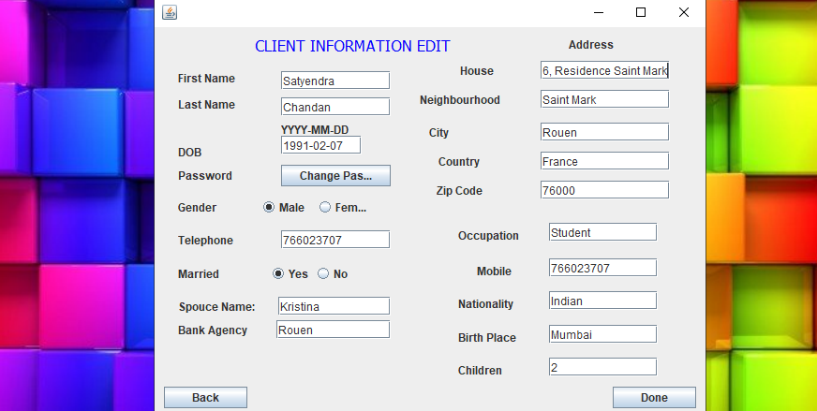

TRANSACTION DETAILS: Here we can see total transaction details including with benefices details.

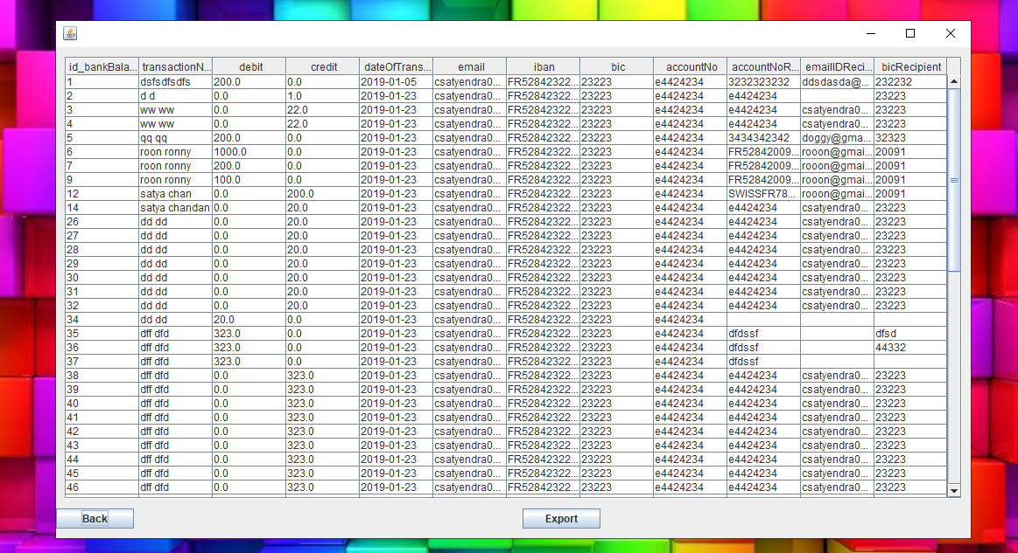

EXPORT TRANSACTION DETAILS:

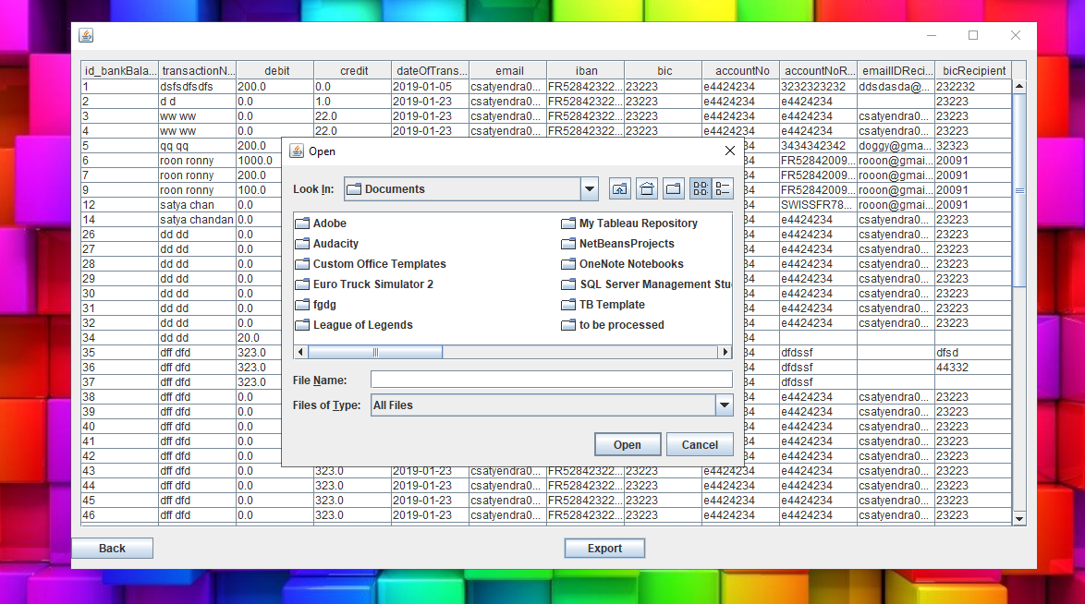

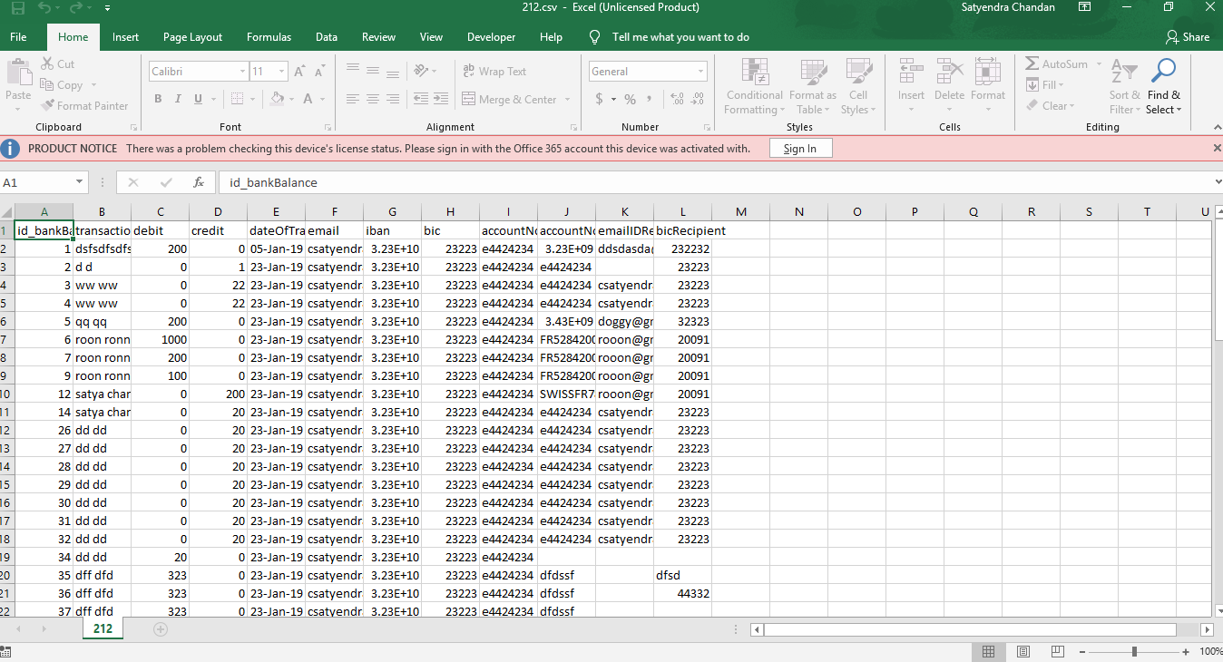

TRANSFER MONEY:

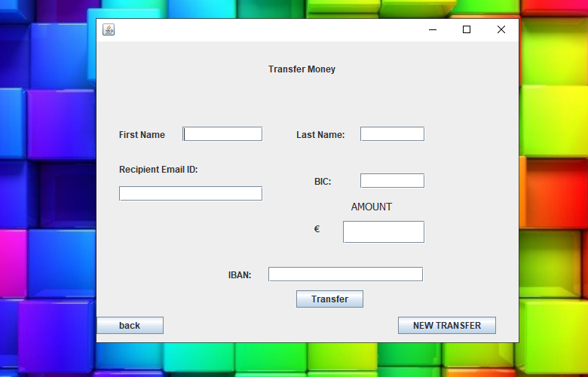

ADD MONEY:

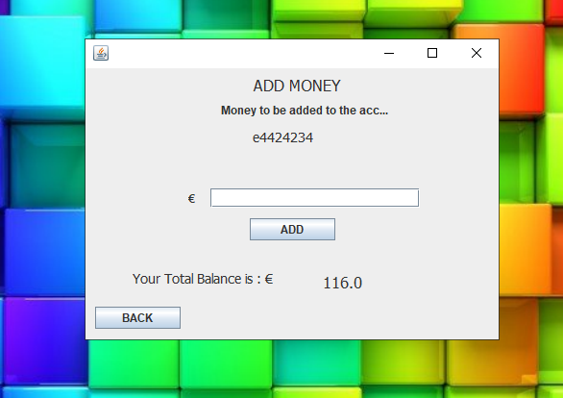

TO VIEW CLIENTS DETAILS BY OFFICE ADVISOR:

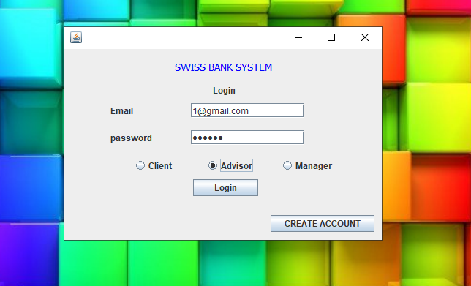 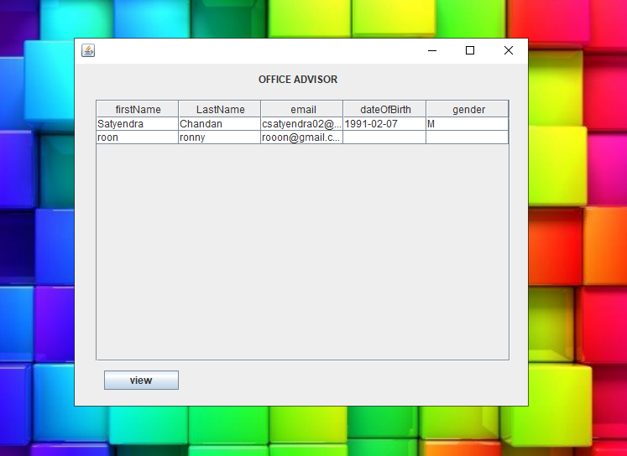

* Office advisor can see client information Office advisor should login by his mail ID & Password and choose advisor option as shown in above image.
* By logging he can see all client names.

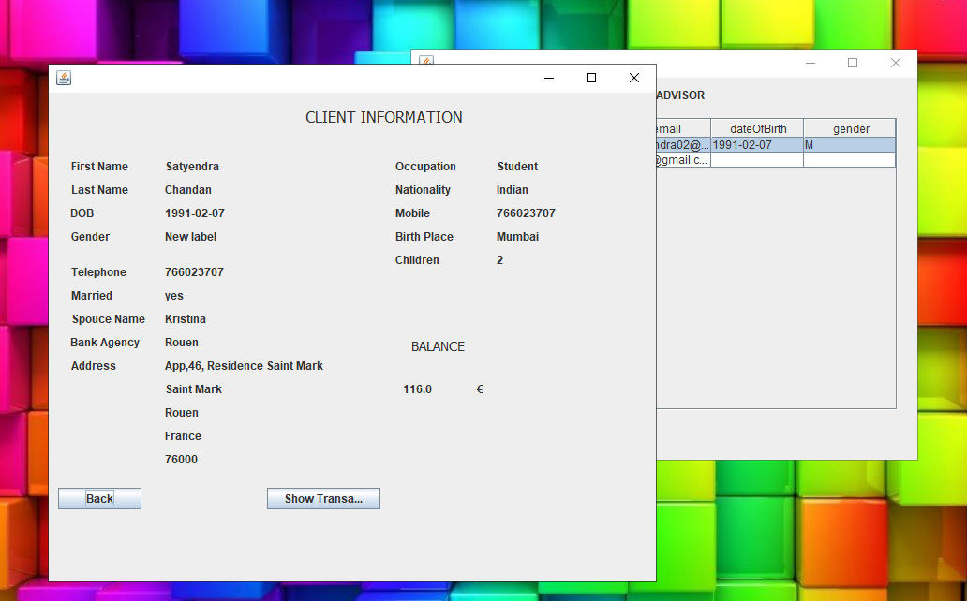

Office advisor can see client information

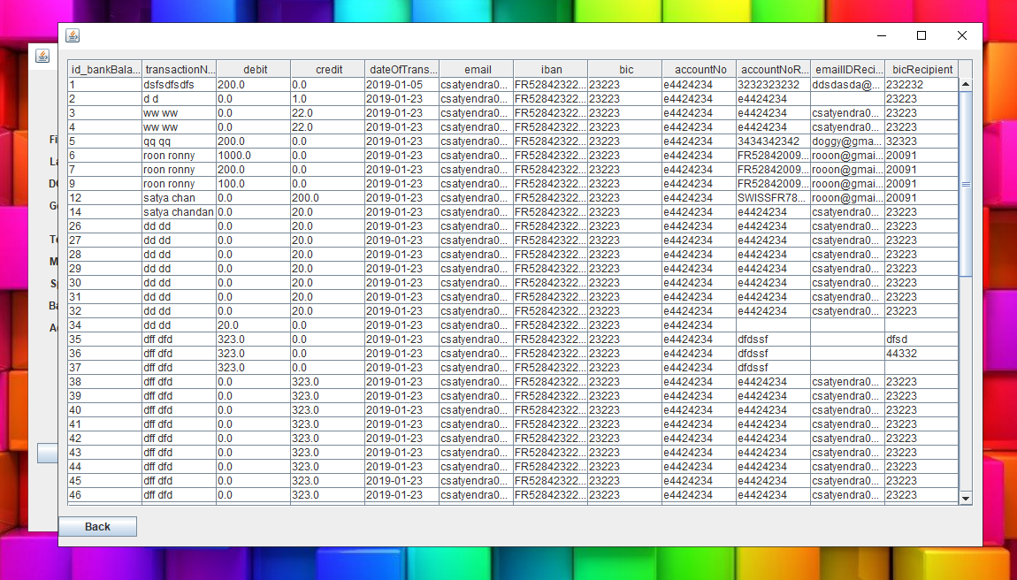

Office advisor can see total transaction details of clients

TO VIEW CLIENTS DETAILS BY MANAGER:

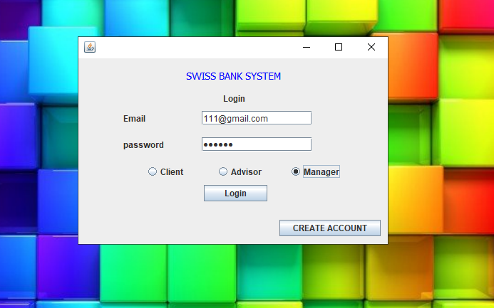 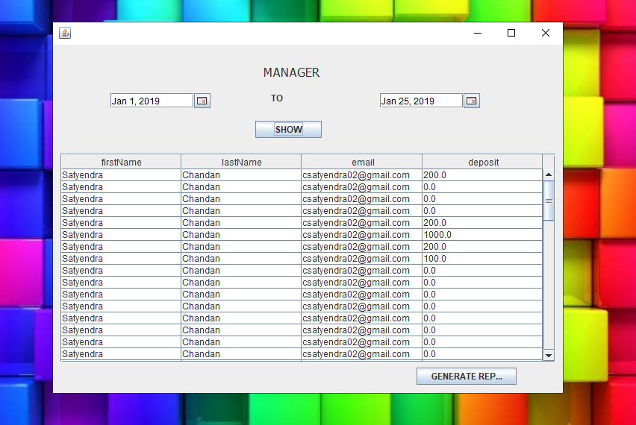

* Manager can see client information by logging with his/her mail ID & Password and choose manager option as shown in above image.
* By logging he can see all client names and their deposited amount.

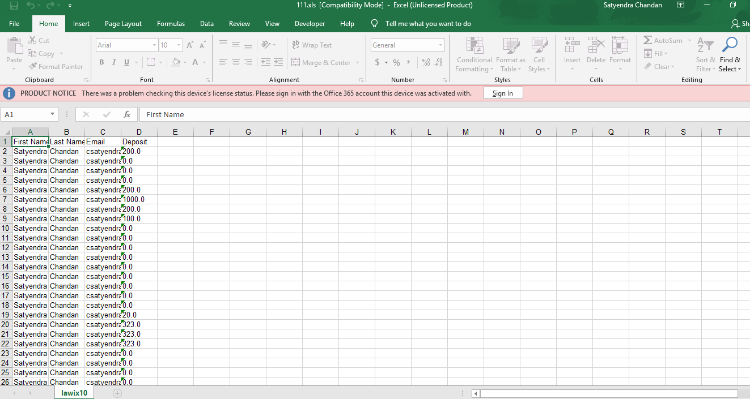

Client deposited amount details in Excel format.

* VALIDATION CHECK

Following message box will display when there is a violation of field validation.

* When the user ID is empty or incorrect;

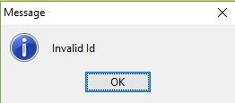

* When the user Password is empty or incorrect;

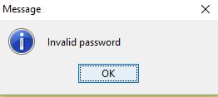

* When the customer name field is empty (it is a mandatory field);

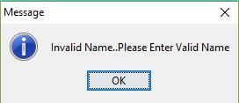

**CONCLUSION AND FUTURE ENHANCEMENT**

**CONCLUSION**

We conclude to build a sealable interface that simplifies the banking system handling. It has the following objectives:

▪ Improved access to all transection and other operation. ▪ Easy access and handling of customers account. 

▪ Detailed access of customer is easy for accountant and all customer and accountant details access is simple for Manager.

 

 **FUTURE ENHANCEMENT**

The file managed containing all the information regarding:

* Customers
* Accountant
* Transactions

It will always be updated with the recently added details.

We are looking forward to add following features to this software:

* Online banking.
* SMS alerts on customer’s registered mobile number.
* Online shopping payment gateway.
* Customer can video chat with accountant or the manager.